HealthANSWERS

Implementation Working Group

Research Assessment Framework

Document Date: 04 February 2020
Document Status: 1.0

Document Control
Version | Summary of Changes | Author | Date
0.01 | Document Creation | Ian Pieper | 21 January 20
0.02 | Updated following feedback | Ian Pieper | 28 January 20
1.0 | Endorsed by Implementation Working Group | Ian Pieper | 04 February 20

Document Approval
Version | Approver | Position | Date
1.0 | Christine Phillips | Interim Director, Centre for Innovation in Regional Health | 04 February 20

HealthANSWERS Research Assessment Framework

Purpose
This document outlines framework to be applied to research proposals that will be supported by the HealthANSWERS collaboration.
Summary
The resources available to support research are limited. There is a need to ensure that the HealthANSWERS collaboration is able to focus research into areas of genuine need and where the collaboration can have meaningful impact.
HealthANSWERS was developed around the foundational principles of:
- collaboration;
- translational health services; and
- health outcomes research.
These principles form the basis of this Research Priority Framework.
Issues
There is a need for a translational, cross-sectoral and cross-jurisdictional health translation research centre in this region. HealthANSWERS remains a valid platform to meet this need.
The Implementation Working Group (IWG) has an opportunity to ensure that the research supported by the HealthANSWERS collaboration delivers high-quality research outcomes that address community needs across the whole of the health sector, including but not limited to:
- primary healthcare networks;
- the aged care sector;
- allied health care providers;
- mental health and psychiatric services; and
- community based health services.

Ethical by Design
Applications supported by the HealthANSWERS collaboration will be ethical by design. The HealthANSWERS collaboration supports research that inculcates ethical choices throughout the design and implementation processes. Research which is ethical by design is based on the principles within authoritative guidance material, such as the:
- National Statement on Ethical Conduct in Human Research;
- Ethical conduct in research with Aboriginal and Torres Strait Islander Peoples and communities: Guidelines for researchers and stakeholders 2018;
- ​​​​Keeping research on track II 2018; and
- Guidelines for Ethical Research in Australian Indigenous Studies.
Research that is designed to be ethical will demonstrate the following:
Meaningful and ongoing community engagement - Applying co-design principles to research selection, design, development, conduct, and dissemination will engage patients and consumers in a manner that identifies genuine need and applies limited resources where they will deliver most value.
Using data to drive decisions - Existing data should support decisions about project selection and include an analysis of community impact and return on investment. Research data developed through research will be made available to support future research. Engagement through the Health Analytics Research Collaborative (HARC) will ensure data governance structures are robust and provide continuous improvement of data management and reuse practices.
Reciprocity - Capacity building is a core benefit of research using the HealthANSWERS model. Taking a reciprocal approach to collaborative engagement builds research literacy within health service end-users as well as research capacity within participating institutions.
Translational - Research supported by the HealthANSWERS collaboration should incorporate the translation of research to address health service needs and responses. Translational research may include understanding of community or systemic needs as well as applying existing research to meet those needs. The Sax Institute Translational Research Framework provides a useful step-wise framework to structure translational research activities.
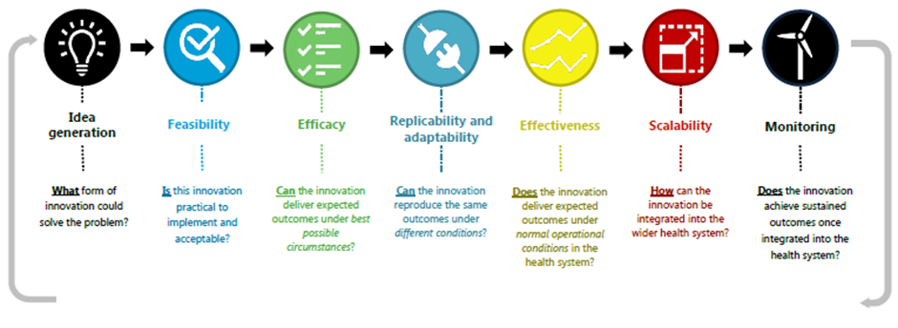
Research excellence - HealthANSWERS supports research based on sound methodological frameworks relevant to the research being conducted. Sampling designs for studies that intend to generalise knowledge must define a sampling framework that identifies cohort and response rate sufficiently to support analysis of the findings and allow for independent examination of the data to verify outcomes.
Innovation - Innovation is at the heart of translational health services. Systems research is needed to develop models of health service delivery that are adaptive to community need and meet the changing environment and to inform government policy and funding responses.
Research Priority Framework
Research supported by the HealthANSWERS collaboration must include the following components:
- Ethical by design;
- Evidence of stakeholder identification, engagement and collaboration;
- Evidence that the research question translates existing data or research into health outcomes that benefit the HealthANSWERS collaboration cohort;
- Detailed methodological framework which promotes transparency of outcomes;
- A data management plan that identifies appropriate data sharing opportunities; and
- A dissemination strategy that demonstrates how the research translate into generalisable health outcomes or service improvements.

